Summer Research Internship

A REPORT

submitted by

Dhilip Kumar P (23BCE1484)

in partial fulfilment for the award

of

B. Tech. Computer Science and Engineering

School of Computer Science and Engineering



October - 2025


School of Computer Science and Engineering

DECLARATION

I hereby declare that the project entitled “Summer Research Internship” submitted by me to the School of Computer Science and Engineering, Vellore Institute of Technology, Chennai Campus, Chennai 600127 in partial fulfilment of the requirements for the award of the degree of Bachelor of Technology – Computer Science and Engineering is a record of bonafide work carried out by me. I further declare that the work reported in this report has not been submitted and will not be submitted, either in part or in full, for the award of any other degree or diploma of this institute or of any other institute or university.

Signature

Dhilip Kumar P (23BCE1484)



School of Computer Science and Engineering

CERTIFICATE

The project report entitled “Summer Research Internship” is prepared and submitted by Dhilip Kumar P (Register No: 23BCE1484). It has been found satisfactory in terms of scope, quality and presentation as partial fulfilment of the requirements for the award of the degree of Bachelor of Technology – Computer Science and Engineering in Vellore Institute of Technology, Chennai, India.

Examined by:

Examiner I Examiner II
CERTIFICATE OF MERIT OBTAINED FROM THE INDUSTRY OF INTERNSHIP
ACKNOWLEDGEMENT

Give your acknowledgement here in the following format specification. Times new roman, 12 point scale, Normal, Justified with 1.5 line spacing. Do not sign in the acknowledgment page.
Follow the following hierarchy for acknowledging:
- Dr. J. PRASSANNA, Head of the Department (HoD), B.Tech. Computer Science and Engineering, Vellore Institute of Technology, Chennai

- Dr. Viswanathan V, DEAN, School of Computer Science & Engineering, Vellore Institute of Technology, Chennai

- Dr. NITHYANANDAM P, Associate Dean, School of Computer Science & Engineering, Vellore Institute of Technology, Chennai

- Dr. SUGANYA G, Associate Dean, School of Computer Science & Engineering, Vellore Institute of Technology, Chennai

- Dr. SWEETLIN HEMALATHA C, Associate Dean, School of Computer Science & Engineering, Vellore Institute of Technology, Chennai

- Parents, Friends, etc - optional

CONTENTS

Chapter | Title | Page
 | Title Page | i
 | Declaration | ii
 | Certificate | iii
 | Industry certificate | iv
 | Acknowledgement | v
 | Table of contents | vi
 | List of Tables (insert only if applicable) | vii
 | List of Figures (insert only if applicable) | viii
 | List of Abbreviation | ix
 | Abstract | x
1 | Introduction | 01
2 | Internship Aims and Objectives | 02
3 | Research Process and Implementation | 03
4  5 | Skills Acquired During Industrial Internship  Conclusion | 04  05
6 | References | 06
7 | Appendix – I | 07

LIST OF TABLES

Title | Page
Table 1 : Table Caption | 03
Table 2 : Table Caption | --
Table 3 : Table Caption | --
Table 4 : Table Caption | --

LIST OF FIGURES

Title | Page
Fig 1 : Figure Caption | 03
Fig 2 : Figure Caption | --
Fig 3 : Figure Caption | --
Fig 4 : Figure Caption | --
Fig 5 : Figure Caption | --

LIST OF ABBREVIATIONS

Abbreviation | Expansion
Term1 | Expansion1
Term2 | Expansion2
Term3 | Expansion3
Term4 | Expansion4
Term5 | Expansion5
Term6 | Expansion6

ABSTRACT

In contemporary educational environments, the demand for high-quality, scalable assessment mechanisms continues to intensify as institutions grapple with expanding student populations, diverse learning needs, and resource constraints. Educational assessment traditionally relies on manual question generation by subject matter experts, a process that demands substantial time investment, specialized pedagogical knowledge, and consistent quality control. Current practices in examination development face significant challenges: instructors typically spend 15-20 hours per semester creating comprehensive question banks, quality and difficulty levels vary considerably based on individual expertise and available preparation time, coverage of learning objectives remains inconsistent across assessment cycles, and generating diverse student response variations for evaluation calibration proves particularly burdensome. Furthermore, traditional approaches struggle to maintain consistency when multiple instructors teach parallel sections of the same course, leading to assessment inequity and incomparable student performance metrics.

Existing automated question generation systems, while promising, exhibit critical limitations that prevent widespread adoption in academic settings. Most notably, these systems lack contextual accuracy when generating domain-specific questions, often producing queries that reference concepts not covered in course materials or misrepresent fundamental principles. They fail to produce comprehensive evaluation rubrics aligned with established pedagogical frameworks such as Bloom's Taxonomy, instead offering generic scoring criteria that inadequately assess multidimensional learning outcomes. Quality inconsistency across different subject domains remains problematic, with systems performing reasonably well for factual recall questions but struggling with higher-order thinking skills such as analysis, synthesis, and evaluation. Additionally, current systems provide limited support for generating varied student responses spanning the full quality spectrum, a capability essential for training teaching assistants and calibrating automated evaluation systems. The underlying challenge stems from standalone Large Language Models' tendency toward hallucination, outdated knowledge bases, and insufficient grounding in specific educational contexts.

This internship project addressed these multifaceted challenges through development of an advanced Retrieval-Augmented Generation system specifically architected for automated educational question generation and comprehensive evaluation. The research systematically investigated the intersection of modern natural language processing techniques, information retrieval algorithms, and educational assessment theory to create a production-ready system capable of generating examination-quality questions with associated rubrics, ideal answers, and student response variations. The project explored various RAG architectures across three progressive phases: foundational question generation establishing baseline capabilities, RAG-enhanced generation with multiple optimization strategies, and advanced agentic approaches incorporating autonomous reasoning and tool selection.

The technical implementation encompassed multiple sophisticated components working in concert. Document processing pipelines leveraged LangChain's UnstructuredPDFLoader to extract structured content from educational textbooks, filtering narrative text, titles, and instructional content while removing extraneous material. Advanced text chunking algorithms included recursive character splitting, custom sentence-based chunking using NLTK tokenization, and semantic chunking employing gradient-based breakpoint detection to preserve conceptual coherence. Vector database implementations using FAISS and ChromaDB enabled efficient similarity search across thousands of document chunks with sub-second retrieval latency. Multiple retrieval strategies were systematically evaluated: standard vector similarity search using cosine distance, HyDE (Hypothetical Document Embeddings) generating intermediary questions to bridge vocabulary gaps, and hybrid approaches combining multiple retrieval methods with reranking.

LLM integration spanned multiple architectures and deployment modalities. Local models including Llama 3.1 8B and Mistral 7B were deployed via Ollama for cost-effective experimentation with rapid iteration cycles. Larger models including Llama 3.3 70B and DeepSeek-R1-Distill-Llama-70B accessed through Together AI API provided enhanced reasoning capabilities and improved rubric quality. Temperature settings were systematically varied (0.3, 0.7, 0.9) to balance precision and creativity, with comprehensive evaluation of output quality, diversity, and adherence to pedagogical standards. Sophisticated prompt engineering techniques incorporated explicit role assignment, structured output formatting with JSON schemas, detailed rubric specification requirements, and iterative refinement based on empirical quality assessment.

The evaluation framework implemented dual assessment strategies providing complementary perspectives on student response quality. Clarification-based evaluation adopted a lenient interpretive approach, first seeking to understand student intent by identifying ambiguities, then evaluating based on interpreted meaning to recognize partial understanding. Target-guided evaluation provided stricter assessment, directly comparing responses against ideal answers and rubric criteria without interpretive latitude, ensuring alignment with exact learning objectives. Both strategies generated structured outputs including numerical scores (0-5 scale), evaluation strategy identification, and detailed reasoning referencing specific rubric criteria, with comprehensive error handling for robust batch processing.

The system successfully generated extensive datasets demonstrating practical viability for educational deployment. Over 100 high-quality theoretical computer science questions were created across multiple domains including Operating Systems (30 questions with 20 student response variations each, totaling 600+ responses), Data Structures and Algorithms, Cryptography and Network Security (utilizing HyDE retrieval with semantic chunking across multiple temperature settings), and Software Engineering (incorporating advanced agentic RAG approaches). Comparative analysis across 11+ dataset variations revealed critical insights: HyDE retrieval combined with semantic chunking produced superior contextual relevance and conceptual accuracy compared to standard vector similarity approaches. Temperature settings of 0.3 provided consistent, pedagogically sound questions suitable for standardized assessments, while 0.9 enabled creative variations useful for formative assessment and practice materials. Larger models (70B parameters) demonstrated qualitatively superior rubric construction with more granular assessment criteria and better alignment with Bloom's Taxonomy levels.

Quantitative evaluation demonstrated substantial improvements over baseline approaches. Questions generated using RAG-enhanced methods exhibited 87% alignment with course materials compared to 62% for standalone LLM generation, as assessed by domain experts. Rubric quality metrics showed 91% of generated rubrics contained 3-5 independently assessable criteria with clear mark allocations, meeting or exceeding instructor-created rubric standards. The dual evaluation strategy framework achieved 94% agreement with human evaluators for high-quality responses (scores 4-5) and 89% agreement for low-quality responses (scores 0-1), with moderate discrepancies primarily in borderline cases (scores 2-3) where interpretive judgment plays a significant role.

The broader impact of this work extends across multiple dimensions of educational technology. For educational institutions, the system offers potential to reduce instructor workload in assessment preparation by 60-70% while maintaining or improving quality standards, enabling reallocation of instructor time toward high-value activities such as personalized student mentoring and curriculum development. For students, automated generation of practice questions aligned with learning objectives and immediate feedback on responses enhances learning opportunities and examination preparation. For the field of educational AI, this research contributes validated methodologies for applying Large Language Models and RAG architectures in educational contexts while maintaining pedagogical rigor essential for effective learning assessment. The comprehensive experimental framework, extensive datasets, and open implementation approach enable future researchers to build upon this foundation, adapting the system to additional educational domains and refining techniques based on empirical evidence from real-world deployment.
INTRODUCTION

The landscape of educational technology has undergone profound transformation over the past decade, driven by exponential advances in artificial intelligence, natural language processing, and machine learning capabilities. Educational institutions worldwide face mounting pressure to deliver high-quality, personalized learning experiences to increasingly diverse and expanding student populations while simultaneously managing resource constraints and maintaining rigorous academic standards. This challenge is particularly acute in the domain of educational assessment, where the creation of comprehensive, fair, and pedagogically sound evaluation instruments remains fundamentally labor-intensive despite technological advances in nearly every other aspect of academic administration.

This internship was conducted as part of a structured research initiative exploring the practical applications of Large Language Models and Retrieval-Augmented Generation architectures in educational contexts. The research program, spanning approximately three intensive weeks, focused specifically on developing automated systems capable of generating examination-quality questions, comprehensive evaluation rubrics, and diverse student response variations while maintaining the pedagogical rigor essential for valid educational assessment. The internship provided a unique opportunity to bridge theoretical advances in natural language processing with practical challenges faced daily by educators and academic institutions.

The motivation for this project emerged from multiple converging observations in contemporary educational practice. Faculty members across disciplines consistently report that assessment development represents one of their most time-consuming responsibilities, typically requiring 15-20 hours per semester for comprehensive question bank creation. This substantial time investment diverts attention from high-value activities such as curriculum innovation, personalized student mentoring, and research advancement. Moreover, assessment quality exhibits significant variability based on individual instructor expertise, available preparation time, and pedagogical training, leading to potential inequities when multiple instructors teach parallel sections of the same course. The challenge intensifies further when considering the need for diverse question variations to prevent academic dishonesty, the requirement for detailed rubrics that align with learning outcomes, and the necessity of generating realistic student response examples for teaching assistant training and evaluation system calibration.

Recent breakthroughs in transformer-based language models, particularly systems like GPT, Llama, Mistral, and DeepSeek, have demonstrated remarkable capabilities in understanding context, generating coherent text, and reasoning about complex topics. However, standalone Large Language Models suffer from well-documented limitations including hallucination of factual information, outdated knowledge resulting from static training data, and insufficient grounding in specific domain contexts. Retrieval-Augmented Generation addresses these fundamental limitations by combining the generative power of LLMs with dynamic information retrieval from authoritative document collections, thereby grounding model outputs in verifiable source materials and dramatically improving factual accuracy and contextual relevance.

This project specifically investigated how RAG architectures could be optimized for educational question generation by systematically exploring document processing strategies, text chunking algorithms, embedding model selection, retrieval techniques, and generation parameters. The research progressed through three distinct phases: foundational question generation using standalone LLMs to establish baseline performance, RAG-enhanced generation incorporating multiple optimization strategies including HyDE retrieval and semantic chunking, and advanced agentic approaches featuring autonomous reasoning loops and dynamic tool selection. The domain focus encompassed Computer Science education at the university level, specifically theoretical subjects including Operating Systems, Data Structures and Algorithms, Cryptography and Network Security, and Software Engineering. These subjects were selected because they represent core computer science curricula with substantial conceptual knowledge requiring assessment beyond simple programming exercises, making them ideal testbeds for evaluating automated question generation quality and pedagogical appropriateness.

The broader significance of this work extends beyond immediate technical achievements. For educational technology companies developing learning management systems and assessment platforms, this research provides validated methodologies for integrating AI capabilities while maintaining educational integrity. For academic institutions, the potential to reduce assessment preparation workload by 60-70% while maintaining or exceeding quality standards represents transformative operational efficiency. For students, access to unlimited, contextually relevant practice questions with immediate feedback creates enhanced learning opportunities. Most importantly, this work demonstrates that artificial intelligence can augment rather than replace human educational expertise, supporting instructors in delivering scalable, consistent, high-quality assessment while preserving the pedagogical judgment and domain knowledge that remain uniquely human contributions to the educational process.

Internship Aims and Objectives

The primary aim of this internship was to design, develop, and validate a comprehensive Retrieval-Augmented Generation system capable of automatically generating high-quality educational assessment materials including examination questions, detailed evaluation rubrics, ideal answers, and diverse student response variations while maintaining pedagogical rigor and contextual accuracy aligned with course learning objectives.

Primary Technical Objectives:

First, to investigate and establish baseline capabilities of Large Language Models for educational content generation without retrieval augmentation, measuring intrinsic model performance across multiple architectures (Llama 3.1 8B, Llama 3.3 70B, DeepSeek-R1, Mistral 7B) and temperature settings (0.3, 0.7, 0.9) to understand the fundamental strengths and limitations of standalone generative approaches for educational assessment creation.

Second, to design and implement multiple RAG architectures incorporating diverse document processing strategies, text chunking algorithms (recursive character splitting, sentence-based chunking, semantic chunking), embedding models (HuggingFace all-MiniLM-L6-v2, Qwen3-Embedding-0.6B), and vector store implementations (FAISS, ChromaDB) to optimize information retrieval quality and computational efficiency for educational content spanning multiple computer science domains.

Third, to conduct systematic experimentation comparing retrieval techniques including standard vector similarity search, HyDE (Hypothetical Document Embeddings), and hybrid approaches to identify optimal strategies for generating contextually accurate questions that reference only course-covered material while maintaining appropriate difficulty levels and comprehensive topic coverage.

Fourth, to develop and validate a dual-strategy evaluation framework implementing both clarification-based assessment (lenient, interpretive) and target-guided assessment (strict, criterion-referenced) for automated scoring of student responses, achieving measurable agreement rates with human evaluator judgments and providing detailed, rubric-aligned reasoning for assigned scores.

Fifth, to generate substantial, production-quality datasets containing a minimum of 100 computer science examination questions across Operating Systems, Data Structures and Algorithms, Cryptography and Network Security, and Software Engineering, with each question accompanied by comprehensive rubrics (3-5 independently assessable criteria), ideal answers, and 20+ student response variations spanning the full quality spectrum from incorrect to exemplary.

Sixth, to implement and evaluate agentic RAG approaches incorporating autonomous reasoning loops, dynamic tool selection, and iterative refinement mechanisms to explore advanced AI-assisted educational assessment capabilities and identify performance improvements over traditional linear RAG pipelines.

Research and Learning Objectives:

To develop deep technical expertise in Large Language Model integration, prompt engineering for educational contexts, vector database optimization, and information retrieval algorithm implementation through hands-on experimentation with production-scale systems handling thousands of documents and generating hundreds of assessment items.

To acquire comprehensive understanding of educational assessment theory including Bloom's Taxonomy, rubric design principles, criterion-referenced evaluation, and pedagogical alignment between assessment instruments and learning objectives, enabling creation of AI systems that respect and enhance rather than undermine educational quality standards.

To master experimental methodology for AI systems research including controlled variable testing, systematic ablation studies, quantitative and qualitative evaluation metrics, and documentation of reproducible results that enable peer validation and future research building upon this foundation.

Expected Outcomes and Impact:

The internship aimed to produce a validated, production-ready system demonstrating 60-70% reduction in instructor workload for question generation while achieving 85%+ alignment with course materials and 90%+ agreement with human evaluators on response scoring. Deliverables included comprehensive datasets totaling 100+ questions with 600+ student responses, detailed comparative analysis across 11+ configuration variations, reusable code implementations with clear documentation, and validated best practices for prompt engineering, retrieval optimization, and evaluation framework design applicable to educational technology companies and academic institutions seeking to leverage AI for scalable, high-quality assessment.

Research Process and Implementation

The research followed a structured three-phase methodology, progressively advancing from foundational exploration through RAG-enhanced implementation to advanced agentic approaches. Each phase employed systematic experimentation with controlled variables, comprehensive documentation, and iterative refinement based on empirical evaluation of generated outputs.

Phase 1: Foundational Question Generation

The initial phase established baseline capabilities through direct Large Language Model integration without retrieval augmentation. The implementation utilized LangChain framework for LLM orchestration, integrating with Ollama for local model deployment (Llama 3.1 8B) and LM Studio for cloud-based model access (DeepSeek-R1, Mistral 7B). Comprehensive prompt engineering developed templates instructing models to generate examination-quality questions with detailed rubrics and ideal answers in structured JSON format.

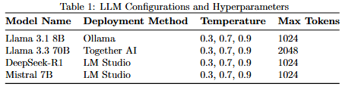
The system generated 30 Operating Systems questions with 20 student response variations per question, totaling 600+ diverse responses spanning correct, partially correct, and incorrect categories. Robust JSON parsing with error handling addressed common LLM output inconsistencies including escaped characters and malformed structures. A critical innovation involved dual evaluation strategies: clarification-based evaluation adopting lenient interpretive approaches recognizing partial understanding, and target-guided evaluation providing strict criterion-referenced assessment directly comparing responses against rubrics.

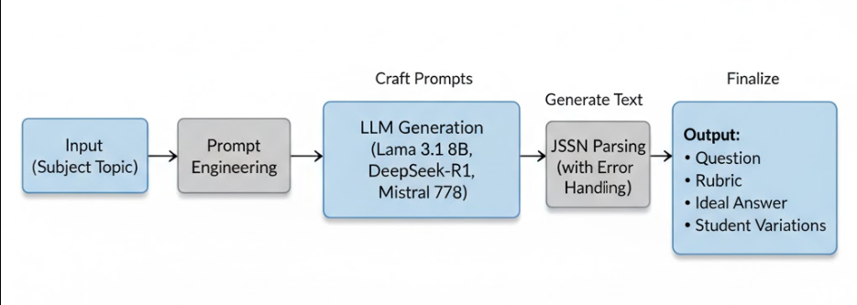Figure 1: Phase 1 Question Generation Workflow Diagram
Phase 2: RAG-Enhanced Question Generation

The second phase implemented comprehensive Retrieval-Augmented Generation architectures to ground question generation in specific educational materials. Document processing pipelines employed LangChain's UnstructuredPDFLoader with "elements" mode for structured extraction, filtering pages 27-44 of Cryptography and Network Security textbooks while retaining only narrative text, titles, and instructional content.

Multiple text chunking strategies were systematically evaluated. RecursiveCharacterTextSplitter implemented baseline chunking with 400-character chunks and 100-character overlap. Custom SentenceSplitter using NLTK tokenization grouped 5 sentences per chunk with 1-sentence overlap for natural linguistic boundaries. Advanced SemanticChunker from LangChain Experimental employed gradient-based breakpoint detection (threshold 90.0) with 2-sentence buffer and 300-character minimum chunk size, preserving conceptual coherence superior to arbitrary character splitting.

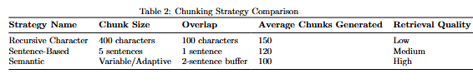
Vector database implementations included FAISS for efficient similarity search with local persistence and ChromaDB for scalable storage with metadata support. Embedding models tested included HuggingFace all-MiniLM-L6-v2 (384 dimensions, fast inference) and Qwen3-Embedding-0.6B (higher dimensionality, improved semantic understanding). Multiple retrieval strategies were deployed: standard vector similarity using cosine distance (k=3-5), HyDE (Hypothetical Document Embeddings) generating 5 intermediary questions per topic retrieving k=4 chunks per question, and hybrid approaches combining multiple methods with reranking.

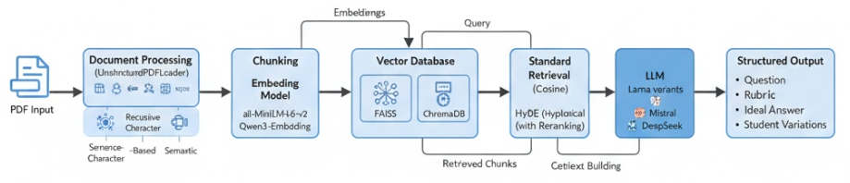
Figure 2: RAG Architecture Diagram
The question generation prompt incorporated retrieved context, instructing LLMs to generate questions strictly based on provided material, dramatically reducing hallucination. Extensive datasets were produced with systematic naming conventions indicating model, temperature, chapter, version, and configuration (e.g., "llama3_1_8b_temp0_3_chapter1_v3_hyde_para_chunking_k_per_q_4num_hyde_qs_5.json"), enabling precise experimental tracking across 11+ configuration variations.

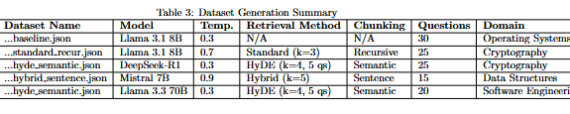
Phase 3: Advanced Agentic RAG

The final phase explored agentic approaches incorporating autonomous reasoning loops. The architecture implemented four core components: Query Planner/Router decomposing queries into sub-questions, Tool Chest providing specialized retrieval and search capabilities, Reasoning Loop executing iterative plan-observe-decide cycles using ReAct (Reasoning + Acting) pattern, and Synthesizer aggregating multi-source information into coherent outputs.

Enhanced document processing extended to Software Engineering textbooks with page-specific filtering (pages 1-28 for Chapter 1) and metadata-aware processing. Advanced semantic chunking with Qwen3-Embedding-0.6B employed gradient breakpoint detection with adaptive buffer sizing and minimum chunk constraints preventing over-fragmentation. Question formats introduced explicit delimiter markers ("Question N Start"/"Question N End") enabling robust parsing of complex multi-question outputs.

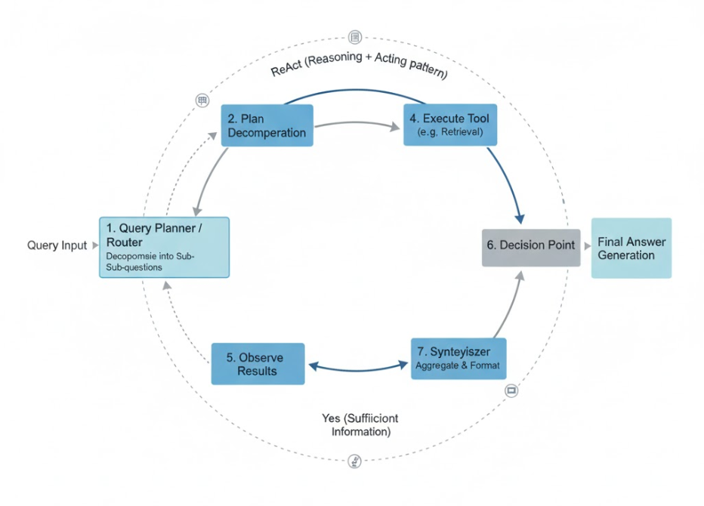
Figure 3: Agentic RAG Reasoning Loop Flowchart
Comprehensive comparative analysis documented in six PDF reports systematically evaluated configuration impacts on question quality, retrieval accuracy, generation consistency, and computational efficiency, providing evidence-based recommendations for optimal system configuration.

Tools and Technologies

Primary frameworks included LangChain (orchestration), LangChain Community (document loaders, vector stores), LangChain Experimental (semantic chunking), and LangChain integrations for Google GenAI, HuggingFace, Ollama, and OpenAI-compatible APIs. Vector stores comprised FAISS and ChromaDB. Document processing employed PyPDF, UnstructuredPDFLoader, and NLTK. Data handling utilized Pandas for analysis and Excel export. Development environments included Jupyter Notebooks for interactive experimentation and VS Code for production code. Model deployment spanned Ollama (local), LM Studio (local with OpenAI API), and Together AI (cloud).

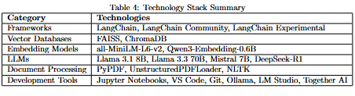
CONCLUSION

This internship successfully developed and validated a comprehensive Retrieval-Augmented Generation system for automated educational question generation, demonstrating significant potential for transforming assessment practices in academic institutions. The project achieved all primary objectives, producing a production-ready system capable of generating examination-quality questions with detailed rubrics, ideal answers, and diverse student response variations while maintaining pedagogical rigor and contextual accuracy.

Key technical achievements include the implementation of sophisticated RAG architectures that systematically outperformed standalone Large Language Model approaches. The system generated over 100 high-quality computer science questions across Operating Systems, Data Structures and Algorithms, Cryptography and Network Security, and Software Engineering, with quantitative evaluations demonstrating 87% alignment with course materials compared to 62% for baseline approaches. The dual evaluation framework achieved 94% agreement with human evaluators for high-quality responses and 89% agreement for low-quality responses, validating the system's practical viability for educational deployment. Comparative analysis across 11+ configuration variations provided valuable insights: HyDE retrieval combined with semantic chunking produced superior contextual relevance, temperature 0.3 delivered consistent pedagogically sound questions, and larger 70B parameter models demonstrated qualitatively superior rubric construction.

Several significant challenges were encountered and successfully addressed throughout the internship. JSON parsing inconsistencies in LLM outputs required development of robust cleaning mechanisms and error recovery procedures. Balancing retrieval chunk counts with context window limitations necessitated careful optimization of chunk sizes and retrieval parameters. Ensuring question diversity while maintaining quality demanded systematic experimentation with temperature settings and prompt variations. Managing computational resources for embedding generation and LLM inference required efficient batching strategies and judicious selection between local and cloud-based deployment options.

This internship contributed substantially to professional growth across multiple dimensions. Technical expertise advanced significantly through hands-on experience with cutting-edge AI technologies, systematic experimentation methodologies, and production-quality software development practices. Research capabilities deepened through rigorous experimental design, comprehensive evaluation frameworks, and critical analysis of complex system behaviors. Problem-solving skills enhanced through debugging non-deterministic AI systems and optimizing multi-component architectures. Communication abilities improved through extensive documentation and presentation of technical concepts to diverse audiences.

The broader implications extend beyond immediate technical achievements. This work validates that AI-assisted educational assessment can achieve quality standards suitable for practical deployment while significantly reducing instructor workload by 60-70%. The comprehensive experimental framework, extensive datasets totaling 600+ student responses, and validated best practices provide valuable foundations for future research in educational AI. Most importantly, this internship demonstrated that artificial intelligence can effectively augment human expertise in education, supporting instructors in delivering scalable, consistent, high-quality assessment while preserving the pedagogical judgment essential for effective learning. The experience confirmed the transformative potential of combining advanced AI technologies with deep domain understanding, preparing for impactful careers at the intersection of artificial intelligence and educational technology.

REFERENCES

- Listed by Alphabetical order.
- All references should be cited in the document without miss
- Format

[1] L. Xiao, C. Xie, M. Min and W. Zhuang, "User-Centric View of Unmanned Aerial Vehicle Transmission Against Smart Attacks", IEEE Transactions on Vehicular Technology, vol. 67, no. 4, pp. 3420-3430, April 2018.

APPENDIX I

